Introduction To Linux

1) Create a directory "exercise" inside your home directory and create nested(dir1/dir2/dir3) directory structure inside "excerise" with single command.

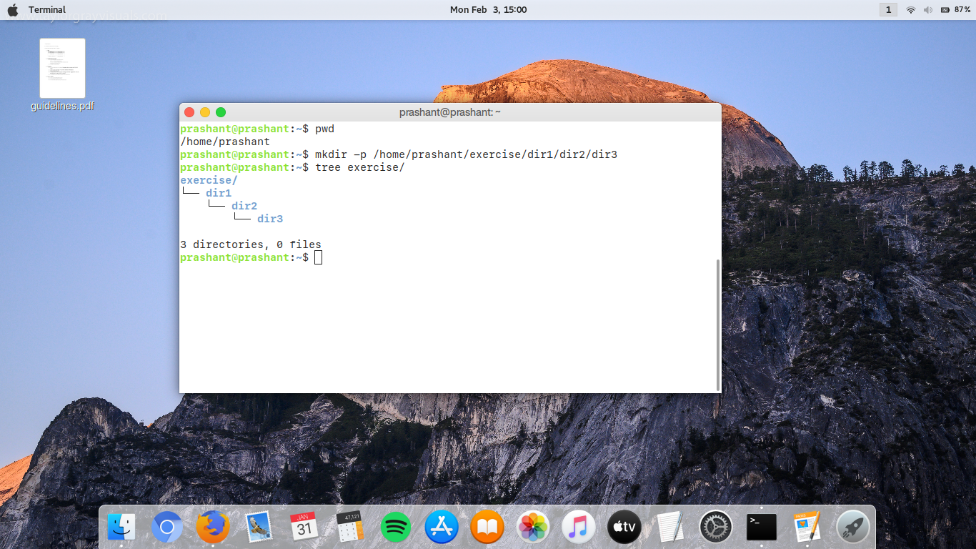

2) Create two empty files inside dir2 directory: emptyFile1,emptyFile2 in single command.

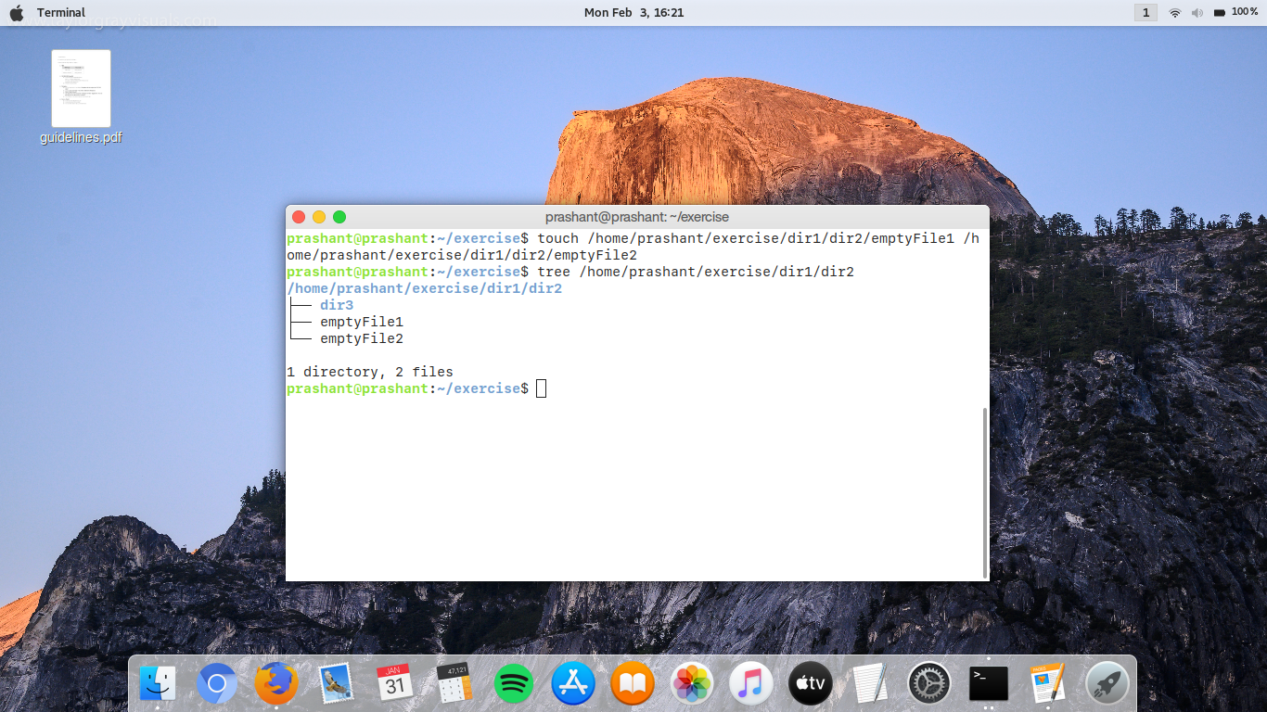

3) Create one file file1.txt containing text "hello world" and save it.

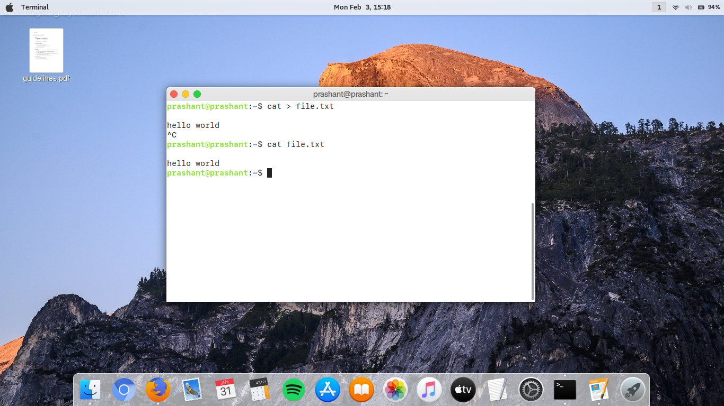

4) Find a "passwd" file using find command inside /etc. copy this files as passwd_copy and then rename this file as passwd_backup.

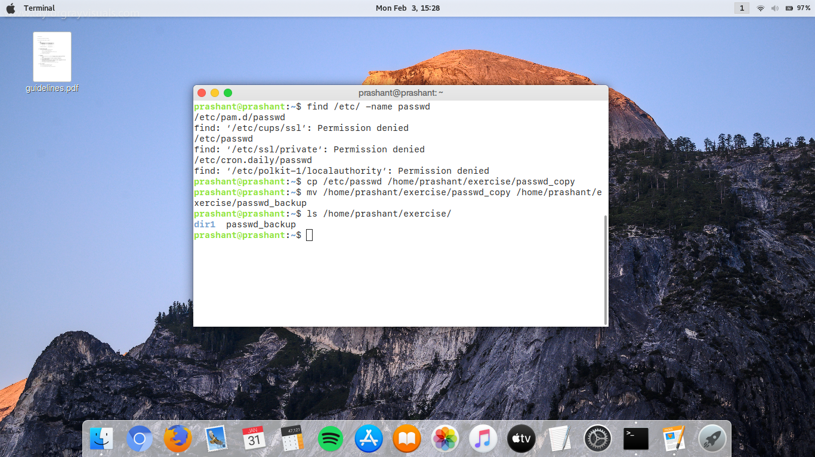

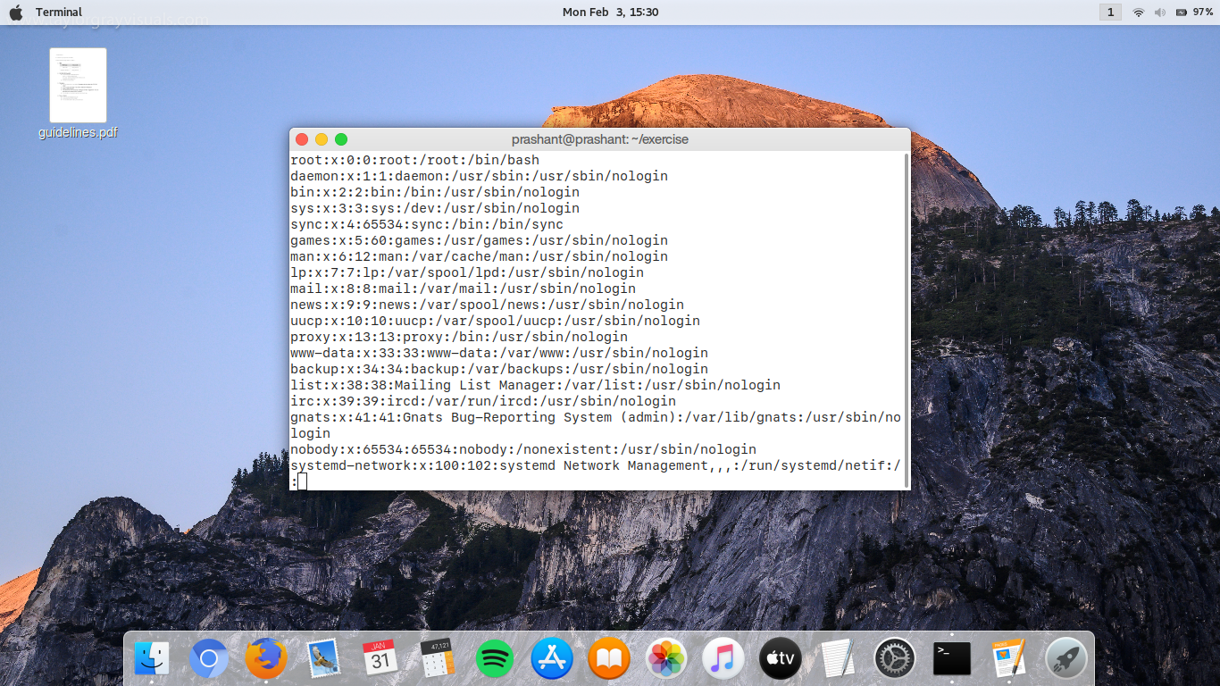5) Try reading passwd_backup file in multiple tools: less,more,cat,strings etc and find the difference in their usage.

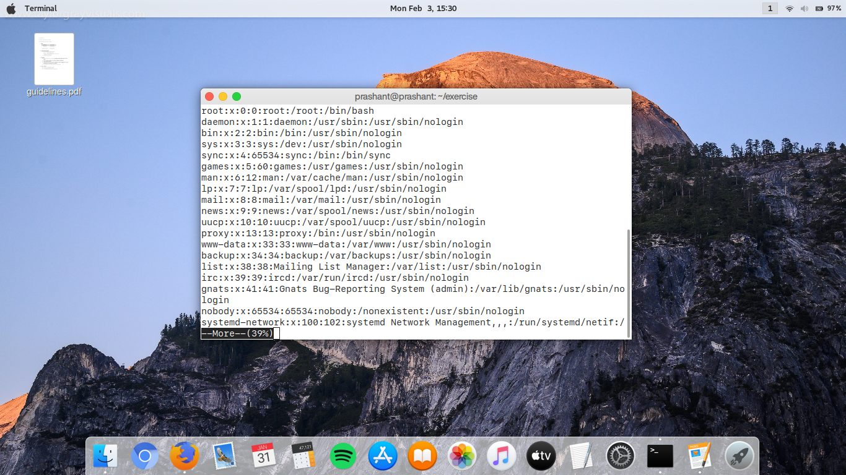

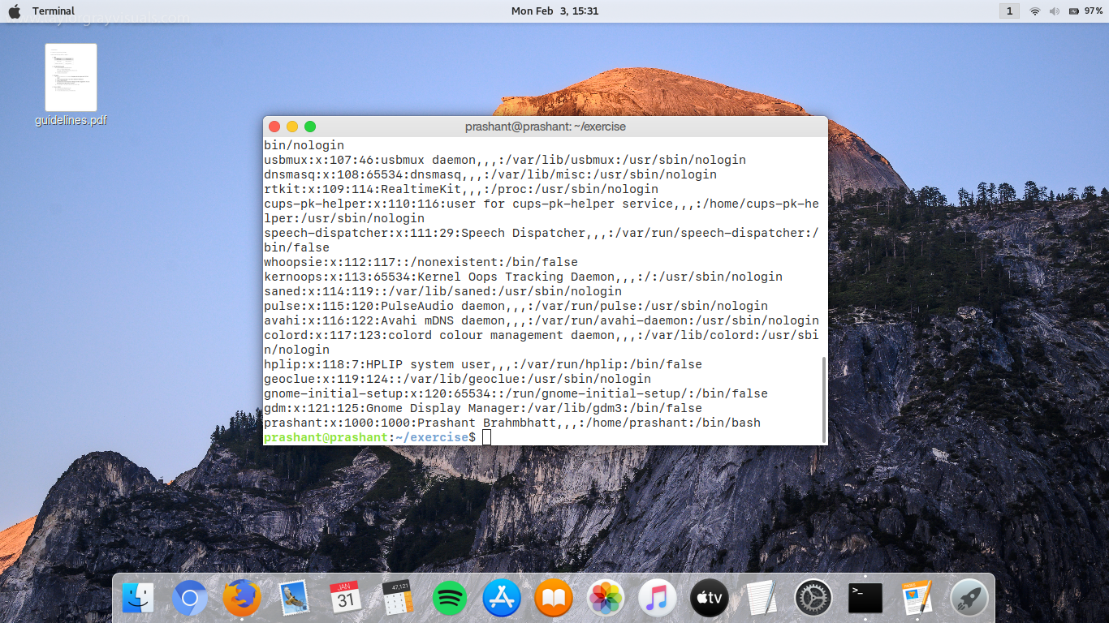

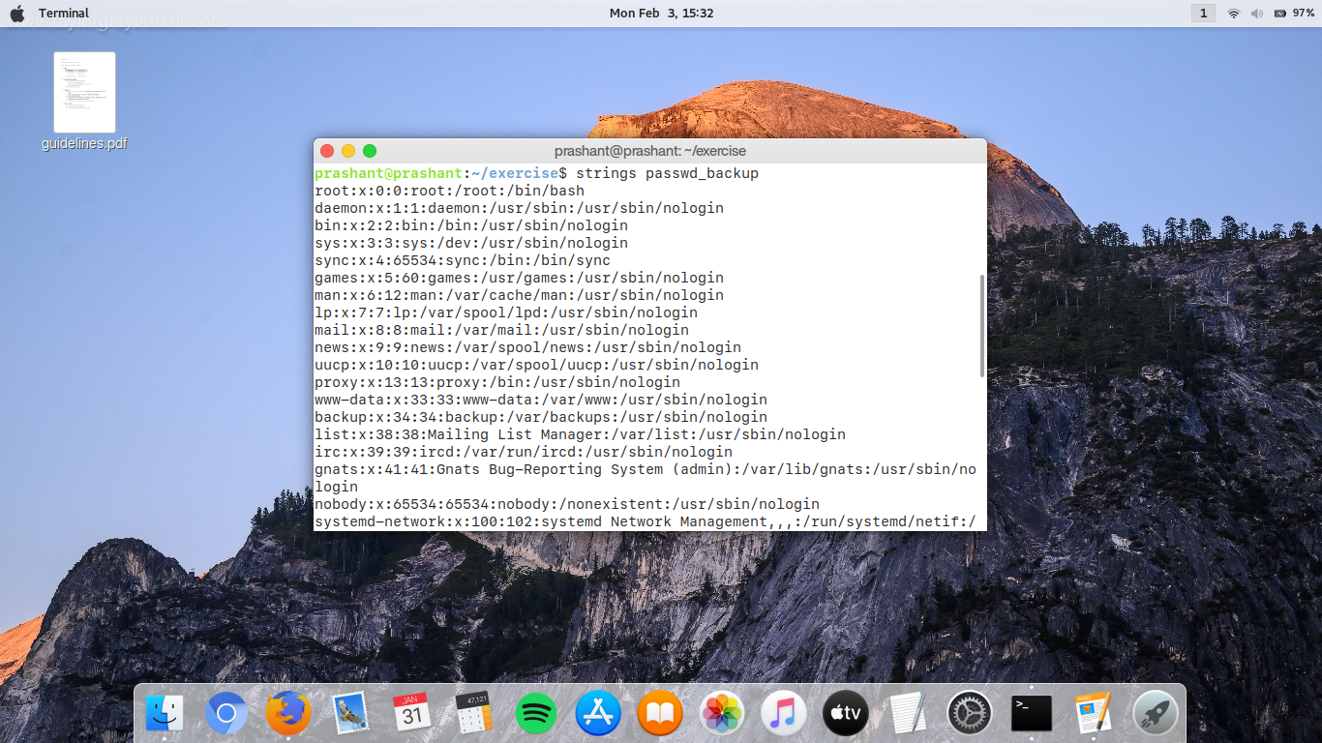

6) Find out the number of line in password_backup containing "/bin/false".

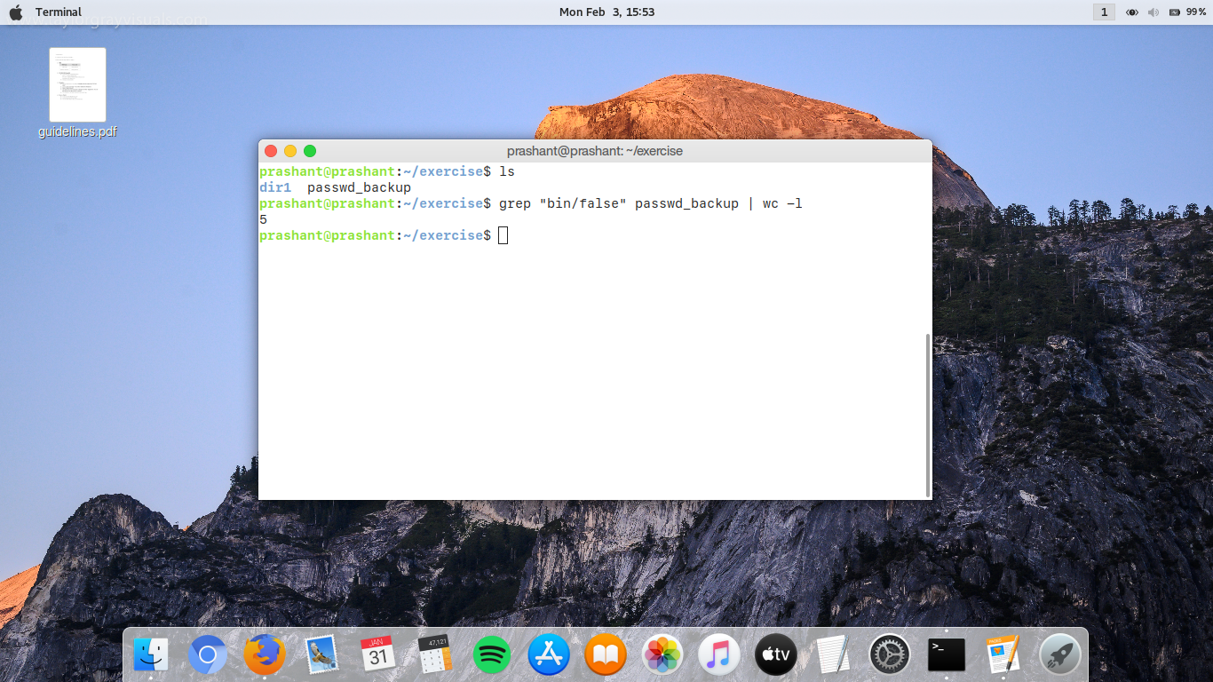

7) Get the first 5 lines of a file “password_backup” and  Redirect the output of the above commands into file "output".

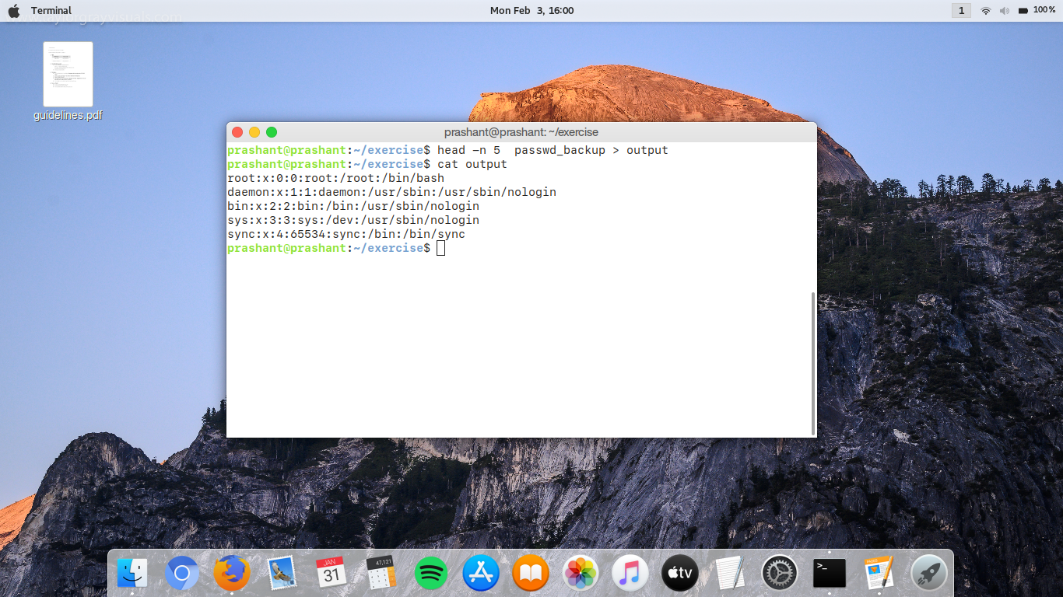

8) Create a "test" user,create its password and find out its uid and gid.

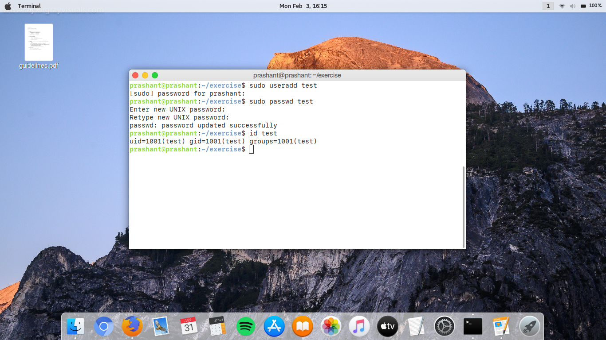

9)